**NAME: AMANOH UGOCHUKWU STUDENT ID: 10019995**

**WEATHER DROID**

**PRODUCT DESCRIPTION**

Weather Droid is a weather guide designed to give you up-to-date weather report for any city in the world. You can choose between cities and also select your preferred temperature unit in preferences.

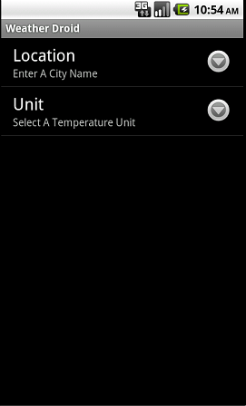 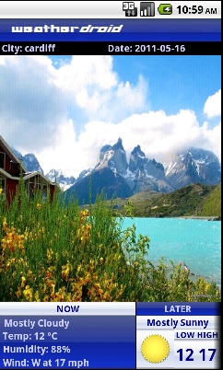 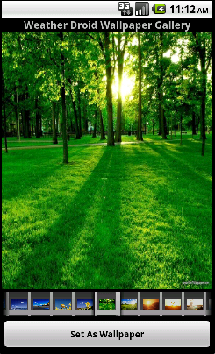

Weather Droid is designed to give you just enough information in one screen to keep, the city name, last date the weather report was updated as well as weather report for the next three days are available.

This application uses animated wallpapers to further describe the current weather condition, you can also view and use these wallpapers in our gallery.

Weather Droid is designed to give users the best experience possible as well as accurate weather information.